**Lab -18 Install and configure Power BI Report Server**

1. Download Power BI Report Server<https://powerbi.microsoft.com/en-us/report-server/>
2. On the On-premises reporting with Power BI Report Server page, select Download free trial.

## Step 1: Install your report server

Installing Power BI Report Server is straightforward. There are only a few steps to install the files.

You don't need a SQL Server Database Engine server available at the time of install. You will need one to configure Reporting Services after install.

1. Find the location of PowerBIReportServer.exe and launch the installer.
2. Select **Install Power BI Report Server**.

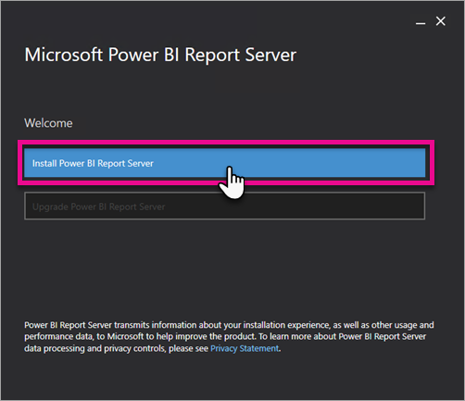

1. Choose an edition to install and then select **Next**.

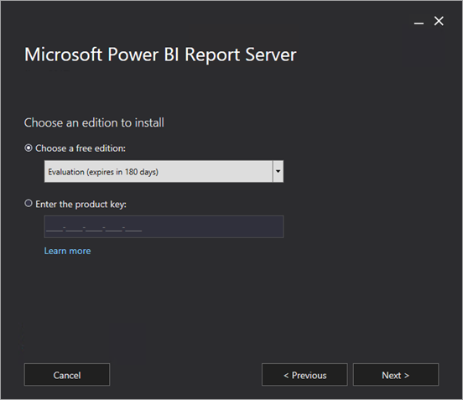

Choose Developer edition for development

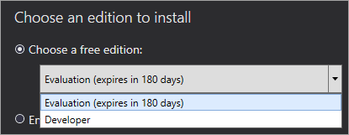

Otherwise, enter the product key that you got from either the Power BI service or the Volume License Service Center. For more information about how to get your product key, see the [Before you install](https://docs.microsoft.com/en-us/power-bi/report-server/install-report-server#before-you-install) section above.

1. Read and agree to the license terms and conditions, then select **Next**.

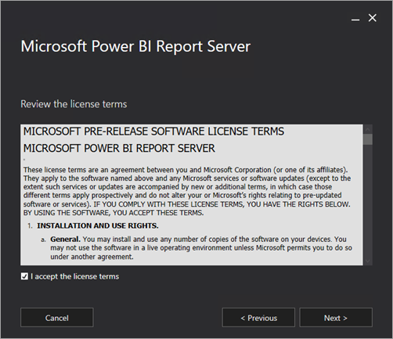

1. You need a Database Engine available to store the report server database. Select **Next** to install the report server only.

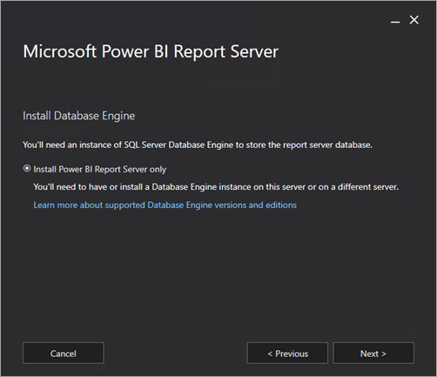

1. Specify the install location for the report server. Select **Install** to continue.

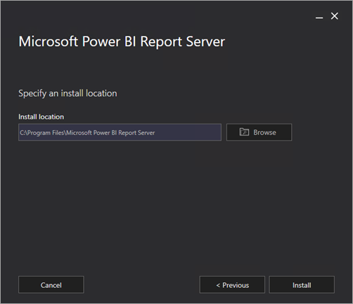

The default path is C:\Program Files\Microsoft Power BI Report Server.

1. After a successful setup, select **Configure Report Server** to launch the Reporting Services Configuration Manager.

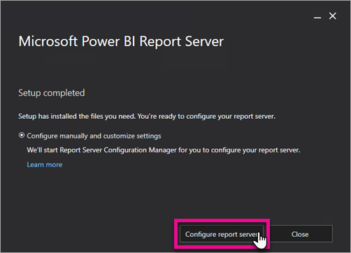

**Step 2 : Configure your report server**

Open ‘Report server configuration Manager’

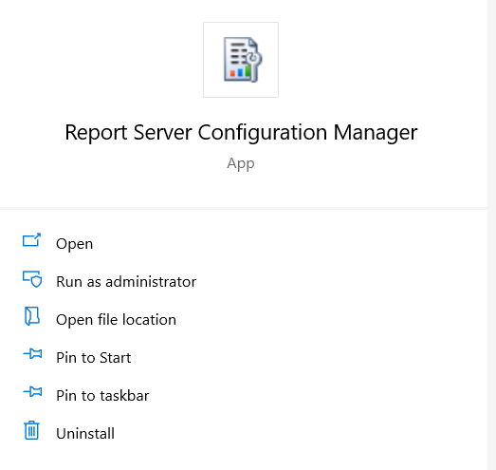

* Open it
* Enter Server name
* Select Report server Instance - PBIRS

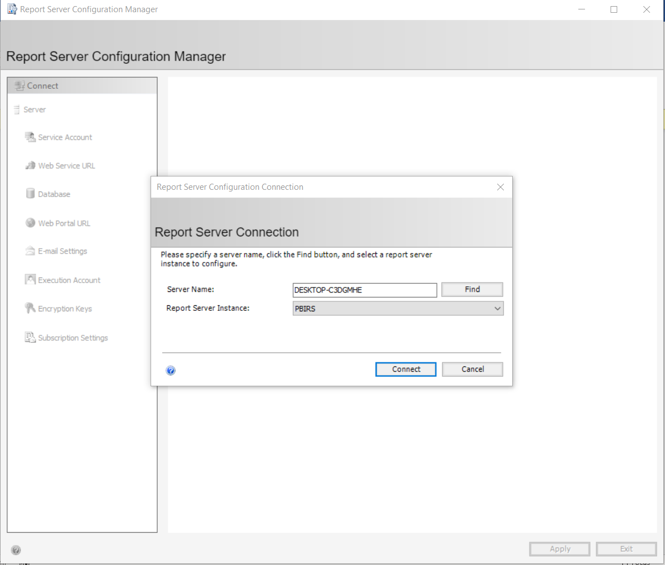

* Click Connect and connect it
* Select Web Service URL
* Enter virtual Directory Name
* Click Apply to configure
* It will generate a URL – http://[desktop-c3dgmhe/ReportServer_PBI - /](http://desktop-c3dgmhe/ReportServer_PBI)

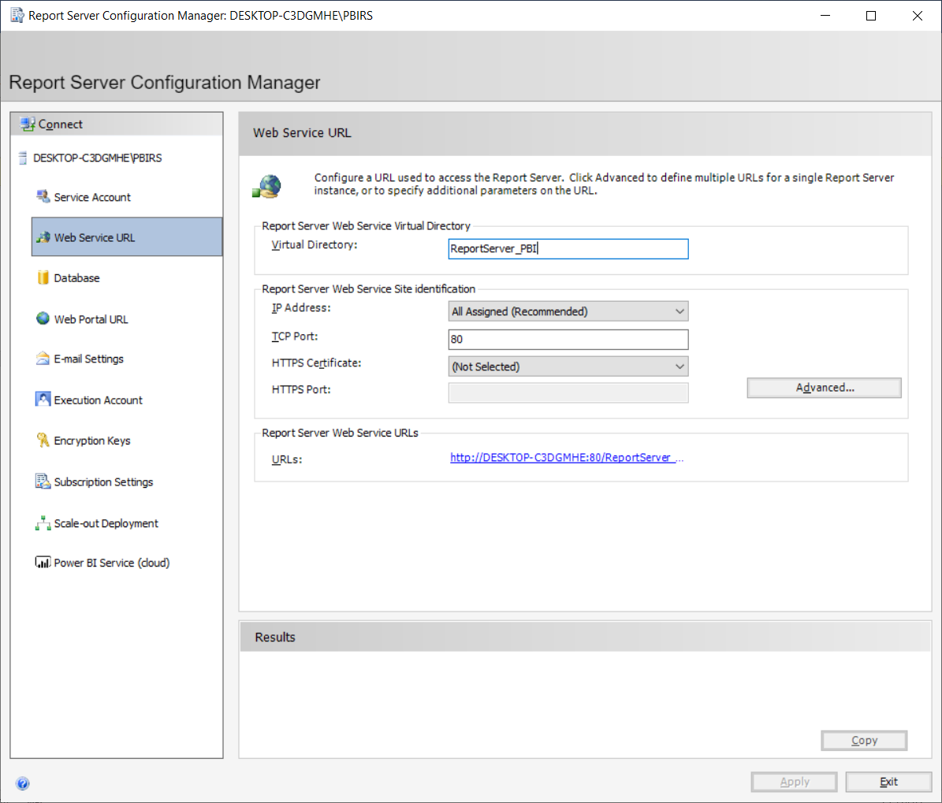

* Go to Database and create new database

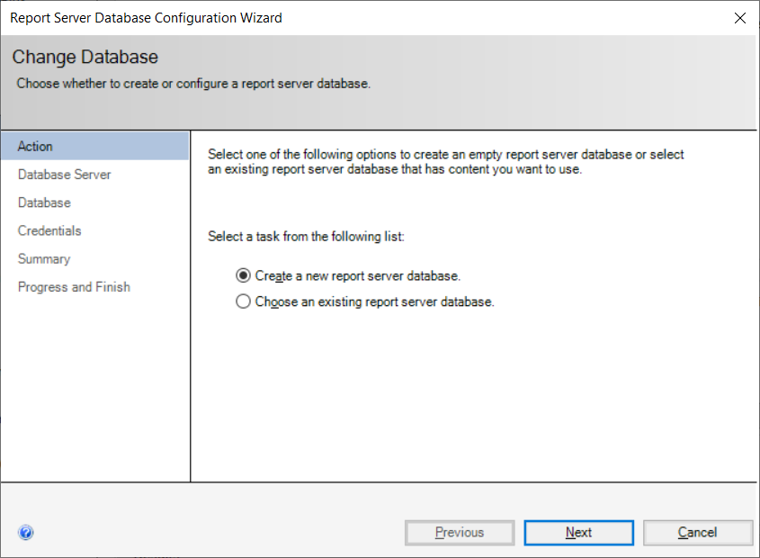

Next

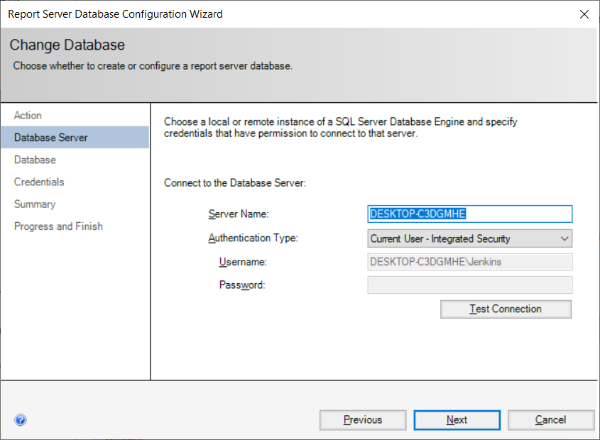

Test Connection

Next and create new database

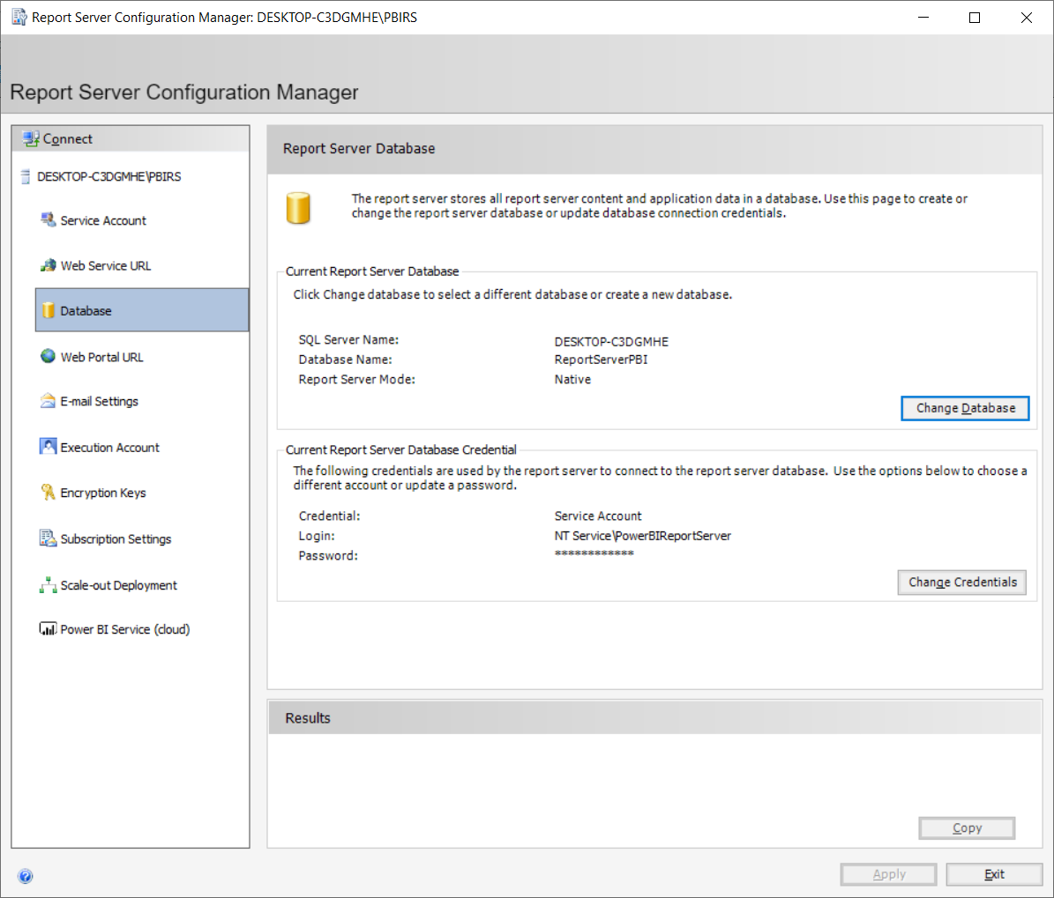

* Select Web Portal URL
* Enter Virtual Directory name
* Click apply to get a URL : <http://desktop-c3dgmhe/Reports_PBI>

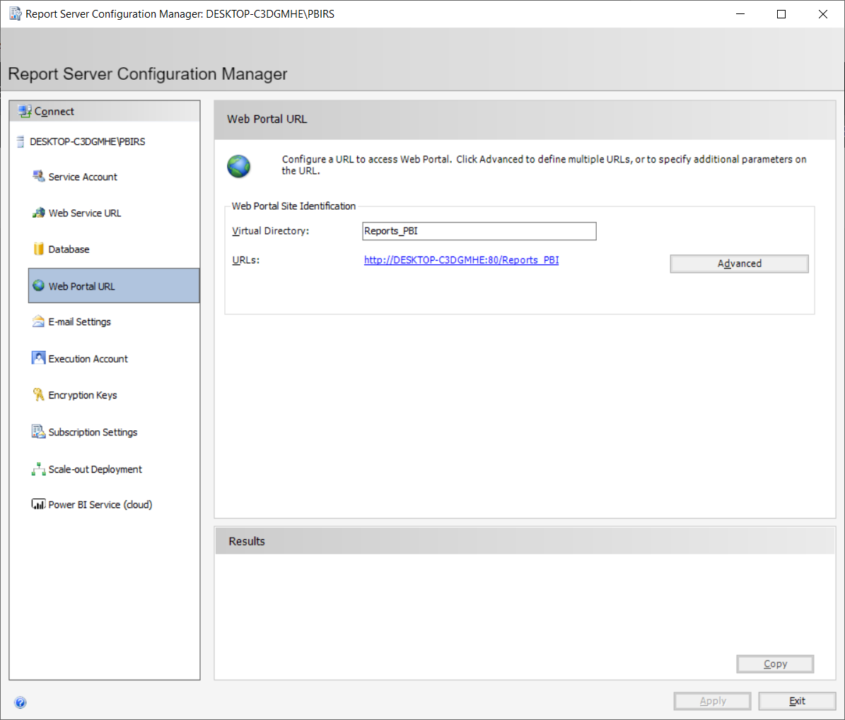

* Now completed the configuration to access the Report Server

**Step 3**

1. Open Browse and open first URL. i.e Report server Service
   1. <http://desktop-c3dgmhe/ReportServer_PBI>

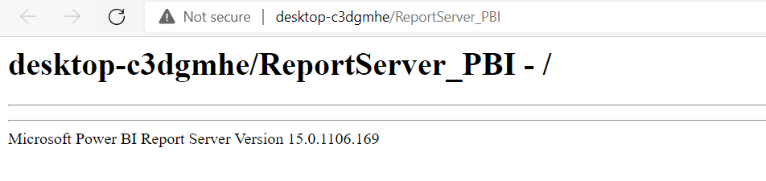

1. Don’t close this browser
2. Then open second URL in browser, i.e., Report server URL
   1. <http://desktop-c3dgmhe/Reports_PBI>

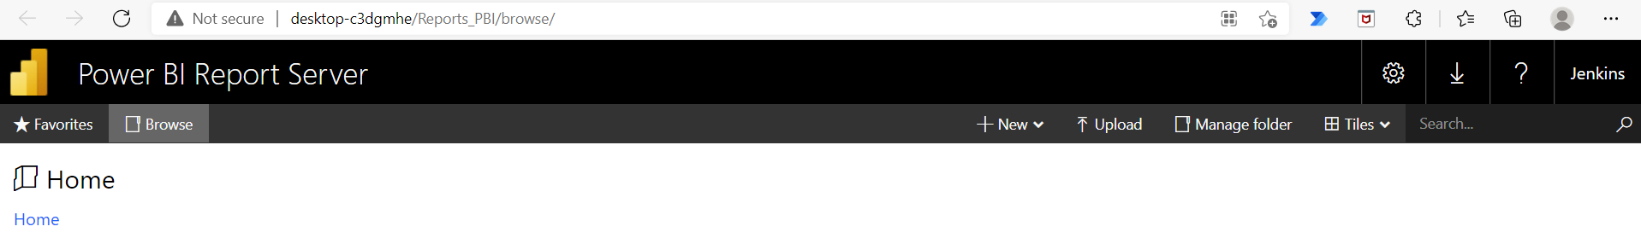

**Step 4**

To create Power BI reports for Power BI Report Server, you need to download and install the version of Power BI Desktop that's optimized for Power BI Report Server. This release is different from the Power BI Desktop used with the Power BI service. For example, the version of Power BI Desktop for the Power BI service includes preview features. Those features aren't in the Power BI Report Server version until they're generally available. Using this release makes sure that the report server can interact with a known version of the reports and model.

Not to worry. You can install Power BI Desktop, and Power BI Desktop for Power BI Report Server, side by side on the same computer.

1. Download and install Power BI Desktop for Report server
2. Microsoft Power BI Desktop (Optimized for Power BI Report Server – May 2021)
   1. <https://www.microsoft.com/en-us/download/details.aspx?id=56723>
3. Create a new report
4. Instead of publish, save as to Power BI report Server.

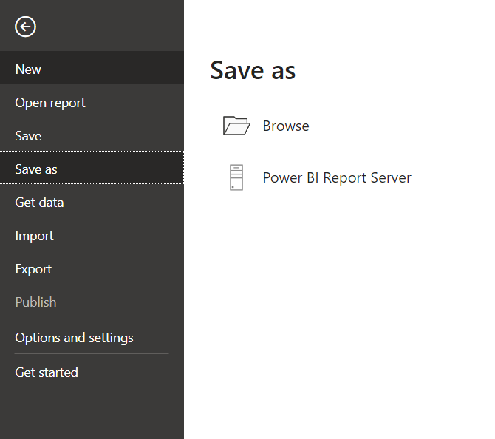

Then refresh Report server page and you can able to see your report.

Click and open the report

